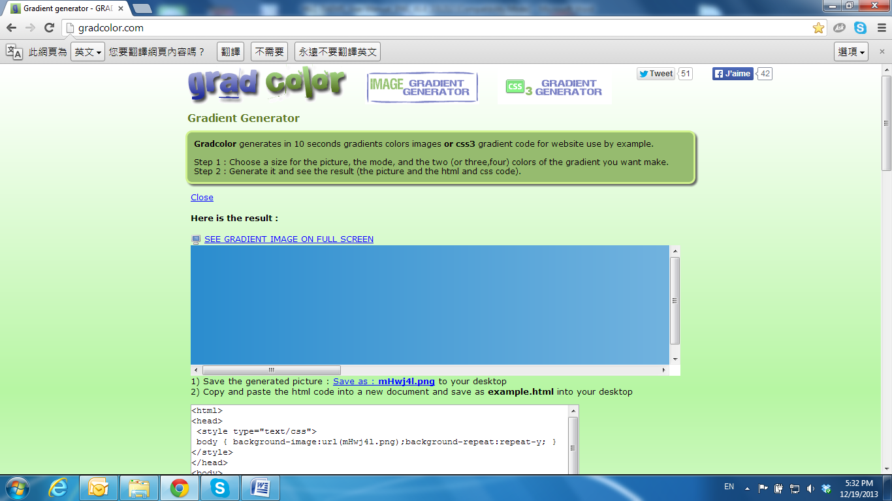

Warnings, Cautions and Copyright

WARNING

TO REDUCE THE RISK OF FIRE OR ELECTRIC SHOCK, DO NOT EXPOSE THIS PRODUCT TO RAIN OR MISTURE.

DO NOT INSERT ANY METALLIC OBJECT THROUGH VENTILATION GRILLS.

CAUTION

|  |  |  |
| --- | --- | --- |
| j0078979 | CAUTION | j0078979 |
| RISK OF ELECTRIC SHOCK  DO NOT OPEN |
| CAUTION：TO REDUCE THE RISK OF ELECTRIC SHOCK.  DO NOT REMOVE COVER (OR BACK).  NO USER-SERVICEABLE PARTS INSIDE.  REFER SERVICING TO QUALIFIED SERVICE PERSONNEL. | | |

COPYRIGHT

THE TRADEMARKS MENTIONED IN THE MANUAL ARE LEGALLY REGISTERED TO THEIR RESPECTIVE COMPANIES.